**Online Course**

Mr. Rafly was a young and passionate teacher. He loved teaching, especially computer programming, and had been running small classes in his hometown for years. But Mr. Rafly had a big dream—he wanted to share his knowledge with people all around the world. One day, he thought, Why not create my own online learning platform?

He started brainstorming how the platform would work. First, Mr. Rafly knew that every user needed to create an account. They would sign up with a username, email, and some basic personal information. To keep things organized, each user would get a unique user_ID, so their activities on the platform could be tracked easily. Once users were registered, they could browse and enroll in courses. Mr. Rafly planned to offer a wide variety of courses, from programming to art. Each course would have a title, a description, a category, and a price. But Mr. Rafly wanted the learning process to be structured and easy to follow, so he decided that every course should be broken into smaller lessons. These lessons would help students focus on one topic at a time.

But just learning wasn’t enough. Mr. Rafly wanted his platform to include quizzes so students could test what they had learned. Each quiz would be linked to a specific lesson, and the system would record the results—how well the student did and whether they passed. This way, students could track their progress over time and know which areas they needed to improve. Mr. Rafly also wanted feedback from students to improve his courses. So, he added a review feature. After completing a course, students could leave ratings and comments. These reviews would not only help other students choose the right courses but also give valuable insights to instructors for improving their content. Of course, payment was another important part of the platform. Mr. Rafly made sure that every payment was tracked carefully, including the amount, payment method, and status. Each payment was linked to the student’s course registration, so it was easy to see who had paid for what. Mr. Rafly didn’t want to run the platform alone. To create high-quality courses, he partnered with tutors who were experts in different fields. Each tutor had their own area of specialization, like programming, art, or business. This ensured that every course was taught by someone with real knowledge and experience.

After months of hard work, Mr. Rafly finally launched his platform. He was overjoyed to see students from all over the world signing up, completing courses, and leaving positive reviews. For Mr. Rafly, it wasn’t just about creating a business. It was about sharing knowledge and building a community of learners who were eager to grow. And so, Mr. Rafly’s dream became a reality. He not only helped people learn but also made the world a little better by building a bridge to knowledge and opportunity.

**CDM:**

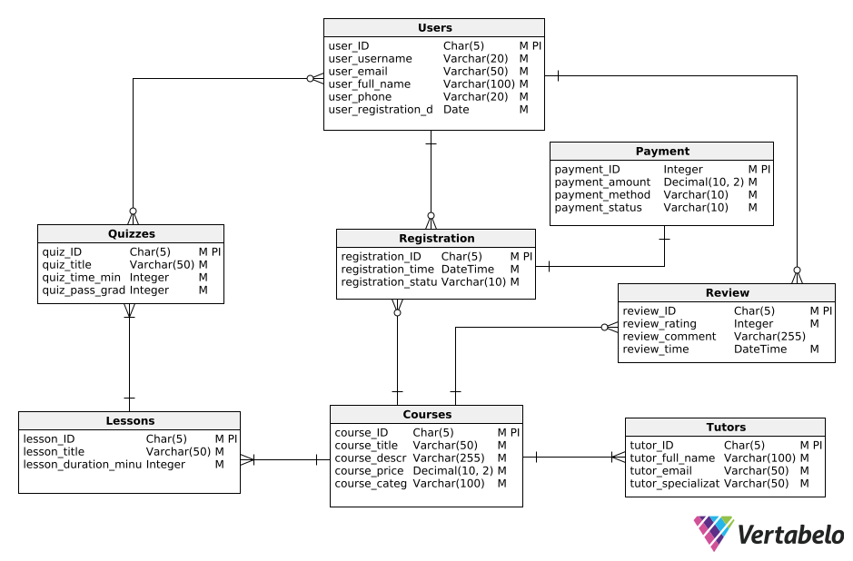

**PDM:**

